

DSS Project Report

Prepared for

Dr. Raafat Saadé

Prepared by

Hao Yin #5043328

skyincookoo@gmail.com

Course

DESC 385

Decision Support System

Date
April 11, 2005
Table of Content

Introduction 3
Objective 3
Data 3
Basic Model: Markowitz Portfolio Theory 3
Knowledge on Portfolio Optimization 6
Effectiveness Test and Result 7
Genetic Algorithm based Knowledge Base 9
Detailed Logic Flow of the Process 10
Prediction Test and Result 10
System Architecture 12
System Limitation 12
Conclusion 13
Appendix: Reference and Resource 14

Introduction
By using Markowitz Portfolio Theory and Genetic Algorithm, a new financial forecasting decision support system to help investor achieve better return is proposed in this paper. The data, model and design of knowledge base will be covered as follows.

Objective
Basically, there are two key decisions to make for every stock investor: what to buy and how many to buy. However, many of them made such decisions by intuition, more or less. This system is designed to optimize investor’s current or planed stock portfolio so as to address above two questions.

Data

Historical data are all easily accessible through Yahoo! Finance, which guarantees the quality of the data. Here, we only use adjusted closing price without bothering issues like dividend and stock split.

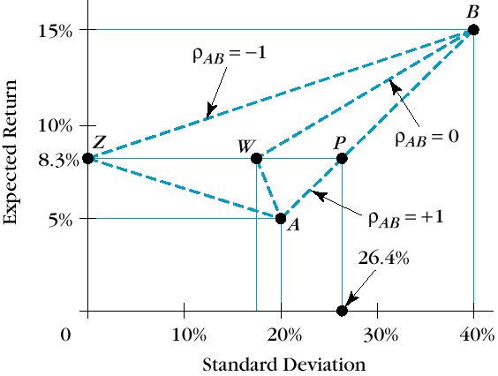
Basic Model: Markowitz Portfolio Theory

The basic statistical information we can get from historical data to characterize stocks are average return and risk (standard deviation). Here, we introduce a new parameter called correlation (ρ) to represent the interaction among stocks. It ranges from 1 to -1.

When we combine two stocks (A and B) to build a simplest portfolio as illustrated below, ρ plays an important role to determine the return and risk of portfolio. When c=1, it means two stocks have perfectly positive relation and will grow up and fall down in same proportion of price, while ρ= -1, they will still interact perfectly in same proportion of price, but in adverse directions. When ρ= 0, two stocks are totally independent. Look back to the following chart, Z, W, and P represent 3 possible portfolios with same weights of stock A and B. The only difference here is ρ. As we can see, given the same return, the smaller the ρ is, the less the risk investors take. At the extreme when ρ= -1, risk is completed hedged. Normally within same market in the real world, 1>ρ>0.

Now we consider all the possible portfolios which include certain numbers of stocks with all kinds of possible weights of stocks included, and then mark them on Return-Risk chart. We will finally find there’s an upper boundary (the blue curve shown in following chart). For every given level of feasible return, the minimal risk can be achieved at every point on the curve; while same for every given level of feasible risk, the highest feasible return can be found on the curve. This curve is called Efficient Frontier and the portfolios on it are called efficient portfolio.

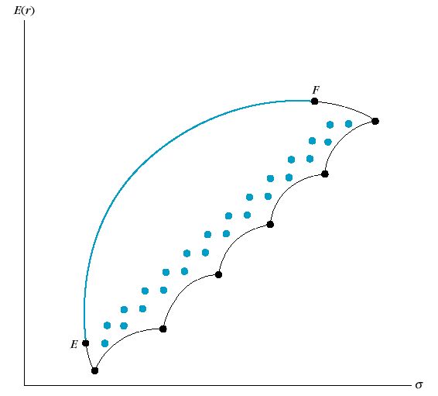

The above discussion is all about risky asset (stock). Now let’s think about a portfolio combining a risky asset and a risk-free asset. If we invest 100% of money into the risk-free asset, there should be no risk at all and we get return at RFR (Risk-Free Rate) as our portfolio return. Now we adjust the weight by putting part of risky asset into the portfolio, we will finally find a linear relationship between return and risk (as shown in following chart), which is logical, since the risky asset is the only contributor to the higher return along with higher the risk. This line is called AAL (Asset Allocation Line).

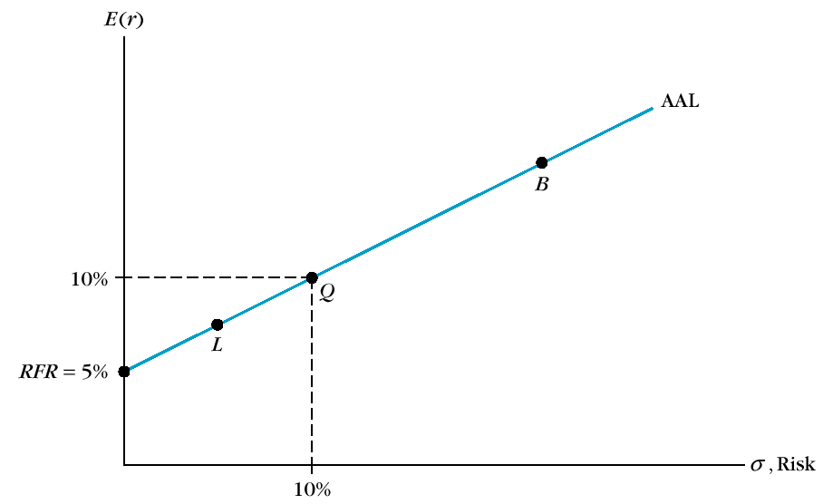

Now we can combine AAL and Efficient Frontier into one diagram, which represents investors’ normal investing strategy by reserving some of money for risk-free asset such as bank saving or treasury bill; or more aggressively, by borrowing risk-free money to invest into a risky asset (margin buy) with higher expectation of return. Look at the following chart, all the points here represent the portfolios of risky assets. When we want to adjust our investing strategy to be timid or aggressive by take the advantage of risk-free asset, we can just move the point along its AAL. Now pay attention to a special point M in the chart, which represents an efficient portfolio, while at the same time on its AAL, attains the highest slope, which means the highest feasible reward-to-variability ratio. We call this point Optimal Risky Portfolio and the AAL of that point is called Optimal CAL (Capital Allocation Line). This portfolio is an investor’s best combination of risky assets to be mixed with safe assets to form the complete portfolio.

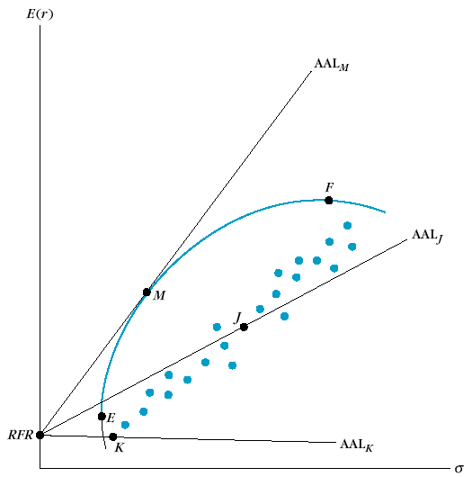

Knowledge on Portfolio Optimization

In order to find the Optimal Risky Portfolio, we need several steps of calculation.

First, we are going to find the return and risk of the portfolio. Weighted return is easy to get, yet weighted variance (=standard deviation^2) is not that straightforward by applying the equation as followed.
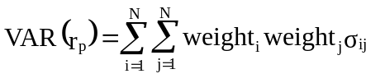
Here, σ_{ij} means the covariance between stock_{i} and stock_{j} within a portfolio. We can use powerful Excel built in statistical function COVAR to get covariance directly from historical data.

Actually the above equation can be expressed in a so-called Variance-Covariance Matrix. By using Excel function SUM, it’s very easy to get the sum of the matrix.

Row N
+x_{N}x_{NσNN}
….
+x_{N}x_{3σN3}
+x_{N}x_{2σN2}
+x_{N}x_{1σN1}
Row N-1
….
….
….
….
….
….

….
….
Col. N – 1
Row 3
+x₃x_{Nσ3N}
+x₃x_{3σ33}
+x₃x_{2σ32}
+x₃x_{1σ31}
Row 2
+x₂x_{Nσ2N}
+x₂x_{3σ21}
+x₂x_{2σ22}
+x₂x_{1σ21}
Row 1
+x₁x_{Nσ1N}
+x₁x_{3σ13}
+x₁x_{2σ12}
+x₁x_{1σ11}
Col. N
Col. 3
Col. 2
Col. 1

Second, AAL can be defined by:
Here, X_{Q} means the weight of risky asset while (1- X_{Q}) means the rest weight of risk-free asset. E(r_{p}) and E(r_{q}) mean the expected return of portfolio and risky asset respectively. (*What’s the difference between expected return and return? Return is the fact in the past, while expected return is the weighted average rate of possible return in future. When analyzing historical data, we replace expected return with return in the equation.) After transferring it a bit, we find the slope of AAL = 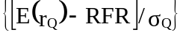

Now we can employ linear programming method through Excel Solver, to iterate all the possible weight combination within a given current portfolio to find the Optimal Risky Portfolio under the constraints:
  - The portfolio should be on Efficient Frontier.
  - The AAL of the portfolio should have the highest value in slope.

Effectiveness Test and Result
I’ve done an initial test in order to validate the model. I’ve selected 10 Canadian stocks and analyzed on their historical data during the past 5 years. Followed table is a summary of the key data, as well as the initial weights I choose based on common sense.

Company name | Ticker (.TO) | Std. Dev (%) | Average Ret. (%) | Weights
Bank of Montreal | BMO | 5.58% | 1.64% | 5.00%
Cascades Inc. | CAS | 6.60% | 0.79% | 15.00%
Canadian tire | CTR | 6.11% | 0.71% | 5.00%
Lowblow | L | 5.43% | 1.55% | 10.00%
Bell Canada | BCE | 5.86% | 0.00% | 5.00%
ATI TECH. | ATY | 19.84% | 2.42% | 5.00%
Shell Canada | SHC | 5.48% | 1.79% | 15.00%
Petro-Canada | PCA | 6.83% | 2.07% | 15.00%
QUEBECOR | IQW-SV | 9.44% | 0.41% | 10.00%
SOBEYS INC | SBY | 8.02% | 1.41% | 15.00%
 |  |  | Total | 100.00%

After performing optimization, I got the result.

 |  | Portfolio: | Original | Optimal Risky
Ticker | Std. Dev (%) | Average Ret. (%) | Weights | Weights
BMO | 5.58% | 1.64% | 5.00% | 25.87%
CAS | 6.60% | 0.79% | 15.00% | 10.88%
CTR | 6.11% | 0.71% | 5.00% | 3.98%
L | 5.43% | 1.55% | 10.00% | 16.42%
BCE | 5.86% | 0.00% | 5.00% | 0.00%
ATY | 19.84% | 2.42% | 5.00% | 8.21%
SHC | 5.48% | 1.79% | 15.00% | 11.57%
PCA | 6.83% | 2.07% | 15.00% | 22.82%
IQW-SV | 9.44% | 0.41% | 10.00% | 0.00%
SBY | 8.02% | 1.41% | 15.00% | 0.24%
Total |  |  | 100.00% | 100.00%
PORTFOLIO STATS
Mean: |  |  | 1.3432% | 1.6744%
Variance: |  |  | 0.1069% | 0.0877%
Std dev: |  |  | 3.2694% | 2.9612%

Look closely at the optimized weights. It suggests that the efficient portfolio needs only 8 stocks rather than previous planned 10 stocks. Clearly, Optimal Risky Portfolio will benefit investors much more than the original one, not even mentioning the savings on transaction fees or commissions.

If we show the result on a Return-Risk chart in a more straightforward way, it will be like:

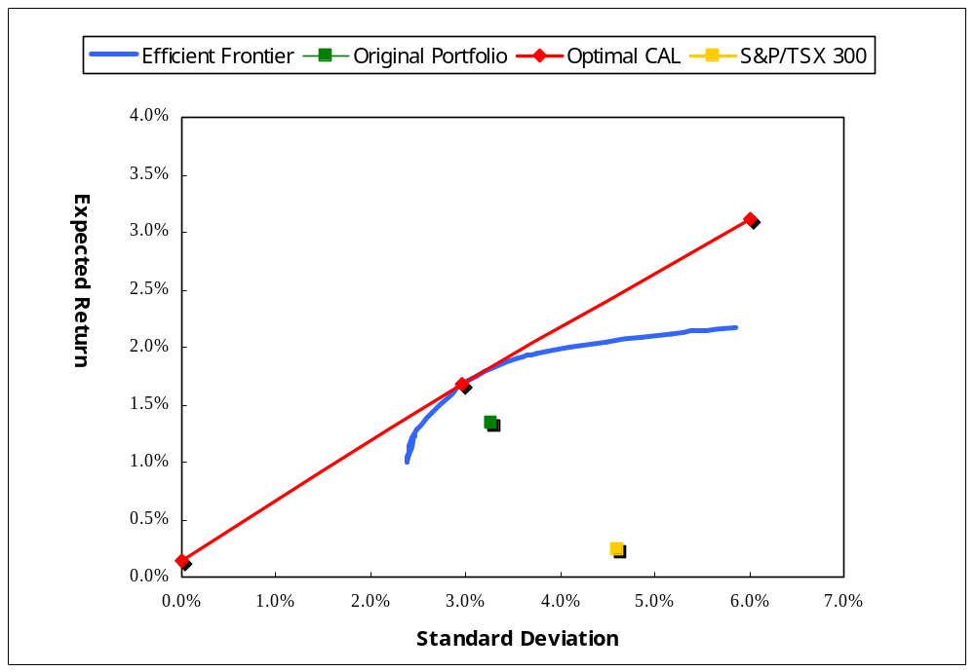

Remember this test is just to prove the effectiveness of the portfolio theory on “after the fact” result. To reveal the real value of the model in practice, we propose a genetic algorithm based process to take advantage of the theory to predict future price trend.

Genetic Algorithm based Knowledge Base
As we can see, the above Markowitz Portfolio Theory based model address the question of “How many to buy” and “What to buy” with a perfect solution. However, MPT only shows what the best solution is for the past. The result itself by nature lacks the power of predictability. In order to predict the certain price behavior, we can develop a multi-agents system with power of genetic algorithm process.

The high-level logic is illustrated as followed chart:

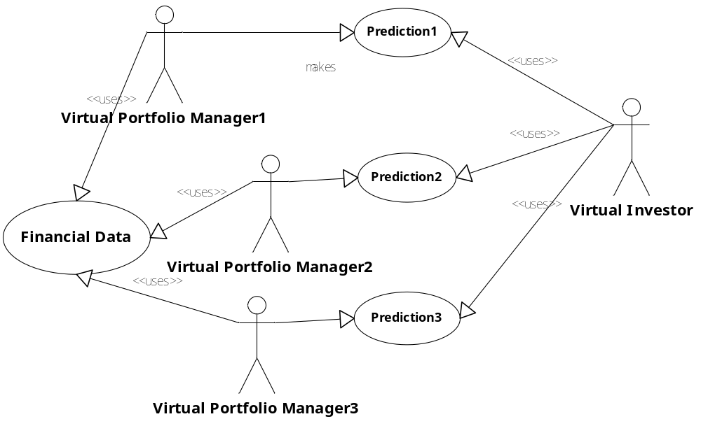

Inspired by the concepts of biological evolution (selection, crossover, and mutation), basically we can create several virtual portfolio managers (agents) with different personalities (financial variables). Let them study the past financial data, then make prediction for the near future. It keeps going on as a loop until a virtual investor evaluates their performance at certain point of time. The virtual investor will select the best one and follow his/her suggestion.

The “micro” process is quite simple, but as time goes by the whole system will evolve to a highly unpredictable and dynamic status, which ideally should trace the trend of the financial market closely.

Detailed Logic Flow of the Process
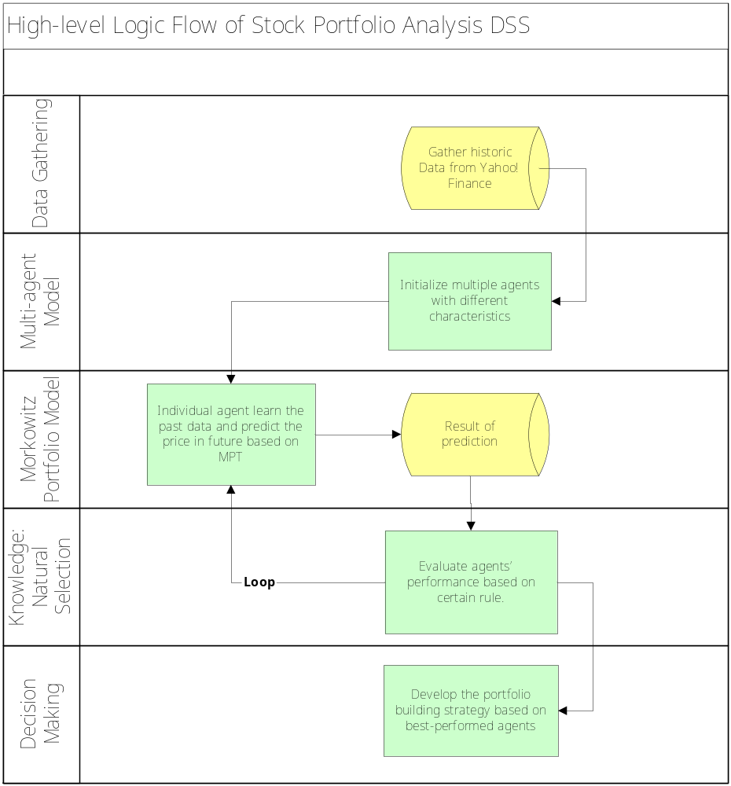

As we can see, this process is dynamic and can evolve forever. The top agents may not be that stable, but we can score on the historical ranks during a period in order to identify those high performance agents in general.

Prediction Test and Result
The prediction test on 10 major Canadian stocks during the past 4 years shows an exciting result: the optimized return/year got from system is about 9% higher than index portfolio with the same stocks. Index portfolio is one of the most popular kinds of fund, in which the weight of stocks are determined by the value of market capital of the stocks.

 | Index Portfolio | S&P/TSX 300 | Stable Portfolio
2001 | 6.47% | -5.87% | 3.51%
2002 | 9.95% | -4.75% | 3.03%
2003 | -0.05% | 8.89% | 14.95%
2004 | 0.85% | 2.68% | 7.13%
Total | 17.21% | 0.95% | 28.61%
Risk | 4.74% | 6.90% | 5.51%

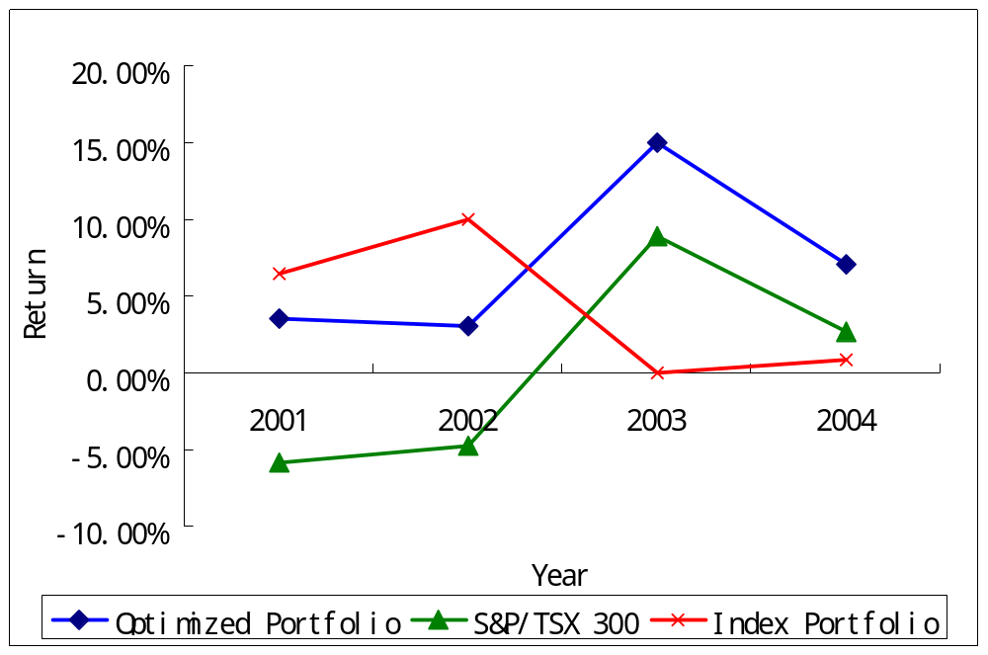

Notice that transaction costs are out of consideration in the test. If including that cost, we estimate the final return will drop down by 1-2%, which is still better than the control funds. Also, a lot of time has been used on tests to determine the level of significance of all kinds of financial variables that may affect the model such as price, volume, transaction cost, level of investors’ greed/fear, interest, P/E ratio, dividend policy, use of short-sell, etc. More tests have to be done in future to keep on working them out.

System Architecture

Currently, the prototype has been done in Excel for quick verification on the effectiveness of the system. Later, we are going to reprogram it by using industry standard technology.

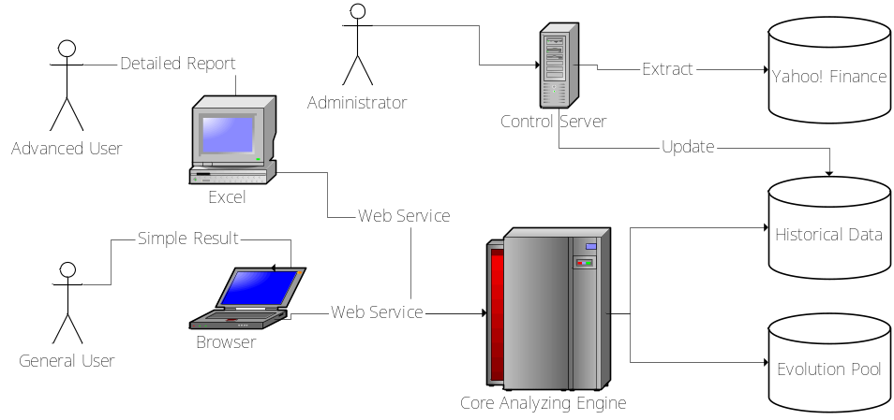

As above shown, we plan to develop an open architecture DSS which can support all kinds of clients and thus meets all kinds of need from different users. A control server is used to undertake ETL (Extract, Form, and Load) task from data source: Yahoo! Finance and then update the Historical Data warehouse. The Evolution Pool is used to store agents’ information as well as intermediate knowledge. The Core Analyzing Engine keeps analyzing historical data then store the knowledge into Evolution Pool. When the client requests an analysis, the engine starts developing an investment strategy from Evolution Pool.

System Limitation
Actually there’s a third investing decision to make in addition to those two I’ve listed at the beginning: when to sell. It’s hard to predict future prices in the long run according to EMH (Efficient Market Hypothesis), which states the prices in any efficient market should random-walk, since new information is unpredictable and the current prices have already reflected all the available information. However, emerging technology such as genetic programming may shed a light on short-term simulation so as to data-mine some underlying information quicker than others.

Future Plan
Further study on virtual portfolio manager’s personalities that lead to decisions on when to sell, as well as on measures of transaction costs, is under way. To accomplish it, we have initially developed a sophiscated simulation system called EvoFund.

Conclusion

As we can see from the result of initial prediction test, this approach, which combines the essence of classical Markowitz Portfolio Theory with famous Genetic Algorithm from AI, really works quite well, not only in analyzing the past but also in future price prediction. This model also control the risk very well to avoid unstable performance.

We hope to promote this model in order to replace widely used fixed-weight index fund to make fund investors better off in long run.

Appendix: Reference and Resource

J. C. Fancis and R. Ibbotson: “Investments: A Global Perspective,” 2002, Ch. 14.

Sengupta, Chandan: “Financial modeling: using Excel and VBA,” 2004. Ch.

C. Gustav Lundberg and A. C. Barna: “Modeling Commodity Trading Expertise,” 1992

R. J. Bauer, Jr. and G. E. Liepins: “Genetic Algorithms and Computerized Trading Strategies,” 1992

Wong, F. S.; Wang, P. Z.; Goh, T. H.; Quek, B. K. “Fuzzy Neural Systems for Stock Selection
,” Financial Analysts Journal; Jan/Feb 1992; pg. 47

Richard J Bauer Jr; F Gregory Fitz-Gerald: “Using genetic programming to design a generalized trading system,” Managerial Finance; 2000; pg. 1

Thomas S. Y. Ho and Sang B. L.: “The Oxford Guide to Financial Modeling,” 2004, Ch. 2

J. G. L. Lazo, M. A. C. Pacheco, M. M. R. Vellasco: “Portfolio Selection and Management using a Hydrid Intelligent and Statistical System,” GA and GP in Computational Finance, pg 221-238, 2002

